PHYSICIAN WORKFORCE IN NEVADA

Nicole Mwalili, MPH
Tabor Griswold, PhD
John Packham, PhD
Simran Kaur, MS
Angel Barboza, BS
Amanda Brown, MPH
Laima Etchegoyhen, MPH
April 2025



Physician Workforce in Nevada – 2025
is a publication from the Nevada Health Workforce Research Center in the Office of Statewide Initiatives at the University of Nevada, Reno School of Medicine.

The mission of the Office of Statewide Initiatives is to improve the health of Nevadans through statewide engagement, education, and research.

The purpose of the Nevada Health Workforce Research Center is to improve the collection and analysis of data on health workforce supply and demand to enhance health workforce planning and development in Nevada.

https://med.unr.edu/statewide

© Copyright University of Nevada, Reno. All rights reserved.
Physician Workforce in Nevada – 2025
Key Findings and Highlights
Physician Workforce in Nevada – 2025 provides current data on the supply and geographic distribution of physicians in Nevada. The report was prepared by the Nevada Health Workforce Research Center in the Office of Statewide Initiatives at the University of Nevada, Reno School of Medicine. The report utilizes the most currently available data from the American Medical Association (AMA), the Association of American Medical Colleges (AAMC), the Accreditation Council on Graduate Medical Colleges (ACGME), the Nevada State Board of Medical Examiners, and the Nevada State Board of Osteopathic Medicine. Please note that the most current physician workforce data from the AMA’s Physician Masterfile is for the calendar year 2023.
Utilizing the most current data from the American Medical Association’s (AMA) Physician Masterfile:
- There are 9,730 physicians in Nevada, including 8,254 allopathic physicians (MDs) and 1,476 osteopathic physicians (DOs) – MDs represent 84.8% of the physician workforce and DOs comprise 15.2% of the physician workforce (Figure 1).
- Among the 7,183 physicians with an active license, there are 7,006 physicians working in patient care (97.5%) and 177 physicians not working in patient care (2.5%) (Figure 1).
- Figures 2 through 6 provide detailed physician workforce data by self-reported specialty and type of professional activity for, respectively, Nevada, Clark County, Washoe County, Carson City, and the state’s fourteen rural and frontier counties.
- Among the 7,183 actively practicing physicians in Nevada, 5,167 work in Clark County (69.0%), 1,623 in Washoe County (21.7%), 149 in Carson City (2.0%), and 244 in the state’s 14 rural and frontier counties (3.3%) (Figures 2 to 6).
- Currently, in 35 of 37 specialty areas tracked by the American Medical Association (AMA), the number of physicians per capita in Nevada is lower than the national per capita rate – exceptions include anesthesiology and forensic pathology (Figure 7).
- Based on the current rates of physicians per population in Nevada and the United States, Nevada would need 2,303 additional physicians to meet the national average (Figure 7).
- Nevada would need an additional 251 family medicine doctors, 411 pediatricians, and 105 psychiatrists to meet the national average for each specialty area (Figure 7).
- The average age of a physician in Nevada is currently 54.8 years – additionally, the average age of physicians in Nevada varies considerably by specialty – for example, the average age of an emergency medicine physician is 46.2 years versus the average age of 56.1 years for obstetricians-gynecologists (Figure 8).
- The percentage of active physicians over the age of 55 is 43.6% of the total physician workforce – the percentage of physicians over the age of 55 varies considerably by specialty – 74.6% of cardiologists are over the age of 55 as compared to 29.4% of emergency medicine physicians (Figure 8).
Utilizing current licensure data from the Nevada State Board of Medical Examiners (MDs) and the Nevada State Board of Osteopathic Medicine (DOs):
- The number physicians licensed by the State of Nevada has increased from 5,469 in 2014 to 7,567 in 2024 – an increase of 2,098 physicians or 27.7% (Figure 9).
- The number of out-of-state physicians licensed by the State of Nevada has increased by 3,614 or 136.3% over the past decade (Figure 9).
- Adjusting for population growth, the number of licensed physicians in Nevada increased from 192.3 to 230.0 per 100,000 population over the past decade – an increase of 19.6% (Figure 10).
- The number of primary care physicians licensed by the State of Nevada has increased from 2,442 in 2014 to 3,141 in 2024 – an increase of 699 or 28.6% over the past decade (Figure 11).
- Over the past decade, adjusting for population growth, the number of licensed primary physicians increased from 86.3 to 95.1 per 100,000 population in Nevada – increase of 10.2% (Figure 12).
According to current data and analysis from the Nevada Health Workforce Research Center, the Association of American Medical Colleges (AAMC), and the Accreditation Council on Graduate Medical Education (ACGME):
- The number of medical school graduates (MD and DO degrees) in Nevada increased from 50 in 2004 to 287 in 2024 – an increase of 237 undergraduate medical education (UME) graduates or 474.0% (Figures 13 and 17).
- Over the past two decades, the number of accredited graduate medical education (GME) sponsoring institutions, residency and fellowship programs, and graduates in Nevada have increased substantially – growth that accelerated with the implementation of the Governor’s GME Grants in 2015 (Figures 14, 15 and 17).
- Since 2004, the number of graduates from accredited residency and fellowship programs in Nevada increased from 49 to 272 – an increase of 233 or 455.1% (Figures 16 and 17).

Utilizing data from the federal Health Resources and Services Administration (HRSA) and population estimates from the Nevada State Demographer’s Office:
- An estimated 2,195,138 Nevadans or 64.9% of the state’s population currently reside in a federally designated primary care HPSA. Twelve of 17 counties in Nevada are single-county primary care HPSAs including 12 of the state’s 14 rural and frontier counties (Figure 24).
- Currently, 3.1 million Nevadans or 91.3% of the state’s population reside in a federally designated mental health HPSA – 15 of 17 counties in Nevada are single-county mental health HPSAs. One hundred percent of the state’s 302,794 rural and frontier residents live in a mental health HPSA (Figure 24).
- The maps contained in Figures 18 through 23 highlight the current geographic distribution and severity of primary care and mental health professional shortage areas (HPSA) in Nevada, Clark County, and northern Nevada – shortages impacting both rural and urban areas of the state.
For additional health workforce information and reports from Office of Statewide Initiatives and Nevada Health Workforce Research, please contact Dr. John Packham at jpackham@med.unr.edu or visit https://med.unr.edu/statewide.

Figure 2: Physician Workforce by Specialty and Professional Activity in Nevada

Specialty | Physicians | Patient Care | Other Professional Activity

 | Total | Total | Office Based | Residents & Fellows | Hospital Staff | Admin | Teaching | Research | Other
Total Physicians | 7,183 | 7,006 | 5,324 | 899 | 770 | 64 | 61 | 23 |  | 29
Family Medicine / General Practice
Family Medicine | 894 | 874 | 703 | 100 | 67 | 5 | 13 | - |  | 2
General Practice | 44 | 40 | 31 | 0 | 9 | 3 | - | - |  | 1
Medical Specialties
Allergy and Immunology | 22 | 22 | 22 | - | - | - | - | - |  | -
Cardiovascular Disease | 141 | 134 | 113 | 10 | 11 | 2 | 3 | 2 |  | -
Dermatology | 76 | 76 | 70 | 3 | 3 | - | - | - |  | -
Gastroenterology | 108 | 108 | 87 | 18 | 3 | - | - | - |  | -
Geriatric Medicine | 51 | 49 | 42 | 1 | 6 | 2 | - | - |  | -
Internal Medicine | 1,543 | 1,508 | 1,072 | 253 | 181 | 18 | 7 | 7 |  | 3
Pediatrics, General | 456 | 440 | 348 | 28 | 63 | 4 | 8 | 2 |  | 2
Pediatrics, Cardiology | 18 | 18 | 17 | - | 1 | - | - | - |  | -
Pulmonary Disease | 97 | 96 | 65 | 13 | 18 | 1 | - | - |  | -
Surgical Specialties
Colon/Rectal Surgery | 16 | 16 | 16 | - | - | - | - | - |  | -
General Surgery | 321 | 316 | 203 | 90 | 23 | 3 | 2 | - |  | -
Neurological Surgery | 25 | 25 | 24 | 1 | - | - | - | - |  | -
Obstetrics/Gynecology | 367 | 359 | 315 | 33 | 11 | 3 | 5 | - |  | -
Ophthalmology | 116 | 113 | 108 | 1 | 4 | - | 3 | - |  | -
Orthopedic Surgery | 214 | 213 | 172 | 28 | 13 | - | 1 | - |  | -
Otolaryngology | 58 | 56 | 44 | 8 | 4 | - | 1 | 1 |  | -
Plastic Surgery | 64 | 64 | 51 | 8 | 5 | - | - | - |  | -
Thoracic Surgery | 26 | 26 | 22 | - | 4 | - | - | - |  | -
Urology | 56 | 52 | 48 | - | 4 | 2 | - | 1 |  | 1
Other Specialties
Anesthesiology | 502 | 496 | 417 | 36 | 42 | 3 | 2 | 1 |  | -
Child and Adolescent Psychiatry | 51 | 46 | 34 | 8 | 4 | - | 4 | 1 |  | -
Diagnostic Radiology | 177 | 170 | 124 | 14 | 32 | 1 | - | - |  | 6
Emergency Medicine | 506 | 501 | 300 | 78 | 120 | 1 | 4 | - |  | -
Forensic Pathology | 9 | 8 | 7 | - | 1 | - | - | - |  | 1
Medical Genetics | 4 | 3 | 3 | - | - | - | - | 1 |  | -
Medical Oncology | 78 | 76 | 67 | - | 9 | 1 | - | 1 |  | -
Neurology | 128 | 125 | 96 | 15 | 13 | - | 2 | 1 |  | -
Nuclear Medicine | 3 | 3 | 2 | - | 1 | - | - | - |  | -
Occupational Medicine | 17 | 16 | 13 | 1 | 1 | - | - | - |  | 1
Pathology, Anatomical/Clinical | 86 | 76 | 60 | 2 | 14 | 2 | 1 | 1 |  | 5
Physical Medicine/Rehabilitation | 146 | 145 | 121 | 11 | 13 | - | 1 | - |  | -
Psychiatry | 285 | 275 | 169 | 67 | 39 | 1 | 4 | 2 |  | 3
Public Health & Gen Prev Medicine | 21 | 15 | 13 | - | 2 | 5 | - | 1 |  | -
Radiology | 80 | 78 | 59 | - | 19 | - | - | - |  | 2
Radiation Oncology | 38 | 36 | 30 | 1 | 5 | - | - | 1 |  | 1
Other Specialties | 56 | 49 | 35 | 6 | 8 | 7 | - | - |  | 1
Unspecified Specialties | 283 | 283 | 201 | 65 | 17 | - | - | - |  | -
Inactive or not classified | 1,787
Not classified | 760

Source: American Medical Association (2025).

Figure 3: Physician Workforce by Specialty and Professional Activity in Clark County

Specialty | Physicians | Patient Care | Other Professional Activity

 | Total | Total | Office Based | Residents& Fellows | Hospital Staff | Admin | Teaching | Research | Other
Total Physicians | 5,167 | 5,053 | 3,811 | 756 | 486 | 42 | 37 | 15 | 20
Family Medicine / General Practice
Family Medicine | 587 | 574 | 454 | 77 | 43 | 4 | 7 | - | 2
General Practice | 37 | 33 | 28 | - | 5 | 3 | - | - | 1
Medical Specialties
Allergy and Immunology | 16 | 16 | 16 | - | - | - | - | - | -
Cardiovascular Disease | 100 | 94 | 82 | 8 | 4 | 2 | 2 | 2 | -
Dermatology | 44 | 44 | 38 | 3 | 3 | - | - | - | -
Gastroenterology | 79 | 79 | 58 | 18 | 3 | - | - | - | -
Geriatric Medicine | 34 | 33 | 27 | 1 | 5 | 1 | - | - | -
Internal Medicine | 1,139 | 1,118 | 813 | 192 | 113 | 13 | 3 | 3 | 2
Pediatrics, General | 356 | 344 | 269 | 25 | 50 | 2 | 7 | 2 | 1
Pediatrics, Cardiology | 17 | 17 | 16 | - | 1 | - | - | - | -
Pulmonary Disease | 74 | 74 | 50 | 12 | 12 | - | - | - | -
Surgical Specialties
Colon/Rectal Surgery | 13 | 13 | 13 | - | - | - | - | - | -
General Surgery | 249 | 246 | 141 | 87 | 18 | 1 | 2 | - | -
Neurological Surgery | 14 | 14 | 13 | 1 | - | - | - | - | -
Obstetrics/Gynecology | 275 | 267 | 230 | 31 | 6 | 3 | 5 | - | -
Ophthalmology | 80 | 79 | 77 | - | 2 | - | 1 | - | -
Orthopedic Surgery | 151 | 150 | 116 | 28 | 6 | - | 1 | - | -
Otolaryngology | 41 | 39 | 30 | 7 | 2 | - | 1 | 1 | -
Plastic Surgery | 46 | 46 | 36 | 6 | 4 | - | - | - | -
Thoracic Surgery | 17 | 17 | 15 | - | 2 | - | - | - | -
Urology | 39 | 36 | 33 | - | 3 | 2 | - | - | 1
Other Specialties
Anesthesiology | 364 | 362 | 298 | 32 | 32 | 1 | - | 1 | -
Child and Adolescent Psychiatry | 29 | 27 | 21 | 4 | 2 | - | 1 | 1 | -
Diagnostic Radiology | 126 | 122 | 93 | 14 | 15 | 1 | - | - | 3
Emergency Medicine | 337 | 334 | 197 | 75 | 62 | - | 3 | - | -
Forensic Pathology | 6 | 5 | 4 | - | 1 | - | - | - | 1
Medical Genetics | 4 | 3 | 3 | - | - | - | - | 1 | -
Medical Oncology | 56 | 56 | 52 | - | 4 | - | - | - | -
Neurology | 93 | 91 | 67 | 14 | 10 | - | 1 | 1 | -
Nuclear Medicine | 1 | 1 | 1 | - | - | - | - | - | -
Occupational Medicine | 9 | 8 | 6 | 1 | 1 | - | - | - | 1
Pathology, Anatomical/Clinical | 64 | 57 | 46 | 1 | 10 | 1 | 1 | 1 | 4
Physical Medicine/Rehabilitation | 100 | 99 | 79 | 10 | 10 | - | 1 | - | -
Psychiatry | 196 | 192 | 120 | 47 | 25 | - | 1 | 1 | 2
Public Health & Gen Prev Medicine | 16 | 12 | 10 | - | 2 | 4 | - | - | -
Radiology | 59 | 57 | 46 | - | 11 | - | - | - | 2
Radiation Oncology | 22 | 21 | 21 | - | - | - | - | 1 | -
Other Specialties | 25 | 21 | 15 | 1 | 5 | 4 | - | - | -
Unspecified Specialties | 252 | 252 | 177 | 61 | 14 | - | - | - | -
Inactive or not classified | 1,231
Not classified | 612

Source: American Medical Association (2025).

Figure 4: Physician Workforce by Specialty and Professional Activity in Washoe County

Specialty | Physicians | Patient Care | Other Professional Activity

 | Total | Total | Office Based | Residents & Fellows | Hospital Staff | Admin | Teaching | Research | Other
Total Physicians | 1,623 | 1,574 | 1,198 | 137 | 239 | 20 | 18 | 6 | 5
Family Medicine / General Practice
Family Medicine | 225 | 221 | 182 | 20 | 19 | - | 4 | - | -
General Practice | 3 | 3 | 2 | - | 1 | - | - | - | -
Medical Specialties
Allergy and Immunology | 6 | 6 | 6 | - | - | - | - | - | -
Cardiovascular Disease | 35 | 35 | 26 | 2 | 7 | - | - | - | -
Dermatology | 26 | 26 | 26 | - | - | - | - | - | -
Gastroenterology | 26 | 26 | 26 | - | - | - | - | - | -
Geriatric Medicine | 15 | 14 | 13 | - | 1 | 1 | - | - | -
Internal Medicine | 337 | 326 | 201 | 61 | 64 | 5 | 3 | 3 | -
Pediatrics, General | 79 | 75 | 63 | 3 | 9 | 2 | 1 | - | 1
Pediatrics, Cardiology | - | - | - | - | - | - | - | - | -
Pulmonary Disease | 19 | 18 | 12 | 1 | 5 | 1 | - | - | -
Surgical Specialties
Colon/Rectal Surgery | 3 | 3 | 3 | - | - | - | - | - | -
General Surgery | 50 | 49 | 43 | 2 | 4 | 1 | - | - | -
Neurological Surgery | 10 | 10 | 10 | - | - | - | - | - | -
Obstetrics/Gynecology | 68 | 68 | 62 | 1 | 5 | - | - | - | -
Ophthalmology | 33 | 31 | 28 | 1 | 2 | - | 2 | - | -
Orthopedic Surgery | 40 | 40 | 37 | - | 3 | - | - | - | -
Otolaryngology | 11 | 11 | 10 | 1 | - | - | - | - | -
Plastic Surgery | 17 | 17 | 14 | 2 | 1 | - | - | - | -
Thoracic Surgery | 8 | 8 | 6 | - | 2 | - | - | - | -
Urology | 13 | 12 | 11 | - | 1 | - | - | 1 | -
Other Specialties
Anesthesiology | 125 | 121 | 106 | 4 | 11 | 2 | 2 | - | -
Child and Adolescent Psychiatry | 19 | 16 | 10 | 4 | 2 | - | 3 | - | -
Diagnostic Radiology | 42 | 41 | 29 | - | 12 | - | - | - | 1
Emergency Medicine | 131 | 130 | 80 | 3 | 47 | 1 | - | - | -
Forensic Pathology | 3 | 3 | 3 | - | - | - | - | - | -
Medical Genetics | - | - | - | - | - | - | - | - | -
Medical Oncology | 16 | 14 | 9 | - | 5 | 1 | - | 1 | -
Neurology | 32 | 31 | 28 | 1 | 2 | - | 1 | - | -
Nuclear Medicine | 2 | 2 | 1 | - | 1 | - | - | - | -
Occupational Medicine | 4 | 4 | 4 | - | - | - | - | - | -
Pathology, Anatomical/Clinical | 17 | 16 | 11 | 2 | 3 | 1 | - | - | -
Physical Medicine/Rehabilitation | 37 | 37 | 35 | - | 2 | - | - | - | -
Psychiatry | 84 | 79 | 46 | 20 | 13 | 1 | 2 | 1 | 1
Public Health & Gen Prev Medicine | 2 | 1 | 1 | - | - | 1 | - | - | -
Radiology | 17 | 17 | 9 | - | 8 | - | - | - | -
Radiation Oncology | 15 | 14 | 9 | 1 | 4 | - | - | - | 1
Other Specialties | 30 | 26 | 19 | 4 | 3 | 3 | - | - | 1
Unspecified Specialties | 23 | 23 | 17 | 4 | 2 | - | - | - | -
Inactive or not classified | 429
Not classified | 135

Source: American Medical Association (2025).

Figure 5: Physician Workforce by Specialty and Professional Activity in Carson City

Specialty | Physicians | Patient Care | Other Professional Activity

 | Total | Total | Office Based | Residents& Fellows | Hospital Staff | Admin | Teaching | Research | Other
Total Physicians | 149 | 148 | 126 | 2 | 20 | - | - | - | 1
Family Medicine / General Practice
Family Medicine | 19 | 19 | 15 | 1 | 3 | - | - | - | -
General Practice | - | - | - | - | - | - | - | - | -
Medical Specialties
Allergy and Immunology | - | - | - | - | - | - | - | - | -
Cardiovascular Disease | 3 | 3 | 3 | - | - | - | - | - | -
Dermatology | 2 | 2 | 2 | - | - | - | - | - | -
Gastroenterology | 3 | 3 | 3 | - | - | - | - | - | -
Geriatric Medicine | 1 | 1 | 1 | - | - | - | - | - | -
Internal Medicine | 28 | 28 | 24 | - | 4 | - | - | - | -
Pediatrics, General | 10 | 10 | 7 | - | 3 | - | - | - | -
Pediatrics, Cardiology | 1 | 1 | 1 | - | - | - | - | - | -
Pulmonary Disease | 4 | 4 | 3 | - | 1 | - | - | - | -
Surgical Specialties
Colon/Rectal Surgery | - | - | - | - | - | - | - | - | -
General Surgery | 8 | 8 | 7 | 1 | - | - | - | - | -
Neurological Surgery | 1 | 1 | 1 | - | - | - | - | - | -
Obstetrics/Gynecology | 10 | 10 | 10 | - | - | - | - | - | -
Ophthalmology | 3 | 3 | 3 | - | - | - | - | - | -
Orthopedic Surgery | 3 | 3 | 3 | - | - | - | - | - | -
Otolaryngology | 4 | 4 | 3 | - | 1 | - | - | - | -
Plastic Surgery | 1 | 1 | 1 | - | - | - | - | - | -
Thoracic Surgery | - | - | - | - | - | - | - | - | -
Urology | 2 | 2 | 2 | - | - | - | - | - | -
Other Specialties
Anesthesiology | 10 | 10 | 10 | - | - | - | - | - | -
Child and Adolescent Psychiatry | 1 | 1 | 1 | - | - | - | - | - | -
Diagnostic Radiology | 2 | 1 | 1 | - | - | - | - | - | 1
Emergency Medicine | 11 | 11 | 7 | - | 4 | - | - | - | -
Forensic Pathology | - | - | - | - | - | - | - | - | -
Medical Genetics | - | - | - | - | - | - | - | - | -
Medical Oncology | 4 | 4 | 4 | - | - | - | - | - | -
Neurology | 2 | 2 | 1 | - | 1 | - | - | - | -
Nuclear Medicine | - | - | - | - | - | - | - | - | -
Occupational Medicine | 1 | 1 | 1 | - | - | - | - | - | -
Pathology, Anatomical/Clinical | 3 | 3 | 2 | - | 1 | - | - | - | -
Physical Medicine/Rehabilitation | 5 | 5 | 4 | - | 1 | - | - | - | -
Psychiatry | 3 | 3 | 2 | - | 1 | - | - | - | -
Public Health & Gen Prev Medicine | - | - | - | - | - | - | - | - | -
Radiology | 3 | 3 | 3 | - | - | - | - | - | -
Radiation Oncology | - | - | - | - | - | - | - | - | -
Other Specialties | - | - | - | - | - | - | - | - | -
Unspecified Specialties | 1 | 1 | 1 | - | - | - | - | - | -
Inactive or not classified | 44
Not classified | 3

Source: American Medical Association (2025).

Figure 6: Physician Workforce by Specialty and Professional Activity in Rural Nevada

Specialty | Physicians | Patient Care | Other Professional Activity

 | Total | Total | Office Based | Residents & Fellows | Hospital Staff | Admin | Teaching | Research | Other
Total Physicians | 244 | 231 | 189 | 4 | 38 | 2 | 6 | 2 | 3
Family Medicine / General Practice
Family Medicine | 61 | 59 | 51 | 2 | 6 | 1 | 2 | - | -
General Practice | 4 | 4 | 1 | - | 3 | - | - | - | -
Medical Specialties
Allergy and Immunology | - | - | - | - | - | - | - | - | -
Cardiovascular Disease | 3 | 2 | 2 | - | - | - | 1 | - | -
Dermatology | 4 | 4 | 4 | - | - | - | - | - | -
Gastroenterology | - | - | - | - | - | - | - | - | -
Geriatric Medicine | 1 | 1 | 1 | - | - | - | - | - | -
Internal Medicine | 39 | 36 | 34 | - | 2 | - | 1 | 1 | 1
Pediatrics, General | 11 | 11 | 9 | - | 2 | - | - | - | -
Pediatrics, Cardiology | - | - | - | - | - | - | - | - | -
Pulmonary Disease | - | - | - | - | - | - | - | - | -
Surgical Specialties
Colon/Rectal Surgery | - | - | - | - | - | - | - | - | -
General Surgery | 15 | 15 | 12 | - | 3 | 1 | - | - | -
Neurological Surgery | - | - | - | - | - | - | - | - | -
Obstetrics/Gynecology | 14 | 14 | 13 | 1 | - | - | - | - | -
Ophthalmology | - | - | - | - | - | - | - | - | -
Orthopedic Surgery | 20 | 20 | 16 | - | 4 | - | - | - | -
Otolaryngology | 2 | 2 | 1 | - | 1 | - | - | - | -
Plastic Surgery | - | - | - | - | - | - | - | - | -
Thoracic Surgery | 1 | 1 | 1 | - | - | - | - | - | -
Urology | 2 | 2 | 2 | - | - | - | - | - | -
Other Specialties
Anesthesiology | 2 | 2 | 2 | - | - | - | - | - | -
Child and Adolescent Psychiatry | 2 | 2 | 2 | - | - | - | - | - | -
Diagnostic Radiology | 7 | 6 | 1 | - | 5 | - | - | - | 1
Emergency Medicine | 27 | 26 | 16 | - | 10 | - | 1 | - | -
Forensic Pathology | - | - | - | - | - | - | - | - | -
Medical Genetics | - | - | - | - | - | - | - | - | -
Medical Oncology | 2 | 2 | 2 | - | - | - | - | - | -
Neurology | 1 | 1 | - | - | 1 | - | - | - | -
Nuclear Medicine | - | - | - | - | - | - | - | - | -
Occupational Medicine | 3 | 3 | 2 | - | 1 | - | - | - | -
Pathology, Anatomical/Clinical | 2 | 1 | 1 | - | - | - | - | - | 1
Physical Medicine/Rehabilitation | 3 | 3 | 3 | - | - | - | - | - | -
Psychiatry | 3 | 2 | 2 | - | - | - | 1 | - | -
Public Health & Gen Prev Medicine | 3 | 2 | 2 | - | - | - | - | 1 | -
Radiology | 1 | 1 | 1 | - | - | - | - | - | -
Radiation Oncology | 1 | 1 | - | - | 1 | - | - | - | -
Other Specialties | - | - | - | - | - | - | - | - | -
Unspecified Specialties | 7 | 7 | 6 | - | 1 | - | - | - | -
Inactive or not classified | 83
Not classified | 10

Source: American Medical Association (2025).

Figure 7: Number of Additional Physicians Needed to Meet the National Average
by Specialty in Nevada

Specialty | Physicians in Nevada | Number per 100,000 Population | Location  Quotient (LQ) | Needed to Meet National Average

 | Number | Nevada | US | Value | Additional Number
Total Physicians | 7,183 | 219.8 | 297.1 | 0.7572 | 2,303
Family Medicine / General Practice
Family Medicine | 894 | 27.4 | 35.9 | 0.7806 | 251
General Practice | 44 | 1.3 | 1.4 | 1.0121 | (1)
Medical Specialties
Allergy and Immunology | 22 | 0.7 | 1.4 | 0.4851 | 23
Cardiovascular Disease | 141 | 4.3 | 9.5 | 0.4636 | 163
Dermatology | 76 | 2.3 | 4.5 | 0.5263 | 68
Gastroenterology | 108 | 3.3 | 5.0 | 0.6775 | 51
Geriatric Medicine | 51 | 9.9 | 11.8 | 0.7797 | 14
Internal Medicine | 1,543 | 47.2 | 53.0 | 0.9116 | 150
Pediatrics | 456 | 63.4 | 126.8 | 0.5257 | 411
Pediatrics, Cardiology | 18 | 2.5 | 4.5 | 0.5871 | 14
Pulmonary Disease | 97 | 3.0 | 4.8 | 0.6304 | 57
Surgical Specialties
Colon/Rectal Surgery | 16 | 0.5 | 0.6 | 0.7721 | 5
General Surgery | 321 | 9.8 | 11.3 | 0.8860 | 41
Neurological Surgery | 25 | 0.8 | 2.1 | 0.3786 | 41
Obstetrics/Gynecology | 367 | 53.9 | 80.1 | 0.8203 | 80
Ophthalmology | 116 | 3.6 | 5.7 | 0.6391 | 66
Orthopedic Surgery | 214 | 6.5 | 8.7 | 0.7749 | 62
Otolaryngology | 58 | 1.8 | 3.4 | 0.5367 | 50
Plastic Surgery | 64 | 2.0 | 2.8 | 0.7284 | 24
Thoracic Surgery | 26 | 0.8 | 2.7 | 0.2971 | 62
Urology | 56 | 1.7 | 3.5 | 0.4988 | 56
Other Specialties
Anesthesiology | 502 | 15.4 | 15.1 | 1.0437 | (21)
Child and Adolescent Psychiatry | 51 | 7.1 | 14.2 | 0.5254 | 46
Diagnostic Radiology | 177 | 5.4 | 7.7 | 0.7171 | 70
Emergency Medicine | 506 | 15.5 | 16.2 | 0.9798 | 10
Forensic Pathology | 9 | 0.3 | 0.2 | 1.2226 | (2)
Medical Genetics | 4 | 0.1 | 0.2 | 0.5096 | 4
Medical Oncology | 78 | 2.4 | 6.4 | 0.3823 | 126
Neurology | 128 | 3.9 | 6.8 | 0.5859 | 90
Nuclear Medicine | 3 | 0.1 | 0.3 | 0.2710 | 8
Occupational Medicine | 17 | 0.5 | 0.6 | 0.9504 | 1
Pathology, Anatomical/Clinical | 86 | 2.6 | 5.2 | 0.5185 | 80
Physical Medicine/Rehabilitation | 146 | 4.5 | 5.4 | 0.8504 | 26
Psychiatry | 285 | 8.7 | 12.2 | 0.7308 | 105
Public Health & Gen Prev Medicine | 21 | 0.6 | 1.1 | 0.6004 | 14
Radiology | 80 | 2.4 | 4.0 | 0.6313 | 47
Radiation Oncology | 38 | 1.2 | 1.7 | 0.7048 | 16
Other and Unspecified Specialties | 339 | 10.4 | 9.6 | 1.1039 | (32)

Source: American Medical Association (2025).
Notes: The shaded figures in this table represent Nevada rates below the national average for a given medical specialty. A location quotient (LQ) for an occupation in Nevada is a measure of the occupation’s concentration within the state or a region of the state compared to the national average. An LQ greater than 1.0 indicates a higher concentration of an occupation than the national average. An LQ below 1.0 represents a lower concentration of an occupation in the state or a region of the state than the national average. Physicians and most health care occupations in Nevada have LQs below the national average (1.0).
Figure 8: Physician Average Age of Physicians by Specialty in Nevada

Specialty | Active Physicians in Nevada | Average Age | Physicians Aged 55 and Over

 | Number | Value | Number | Percent
Total Physicians | 7,183 | 54.8 | 3,134 | 43.6
Family Medicine / General Practice
Family Medicine | 894 | 49.1 | 373 | 41.7
General Practice | 44 | 69.2 | 42 | 95.5
Medical Specialties
Allergy and Immunology | 22 | 67.8 | 12 | 54.5
Cardiovascular Disease | 141 | 57.3 | 101 | 74.6
Dermatology | 76 | 46.1 | 32 | 42.1
Gastroenterology | 108 | 52.4 | 54 | 50.0
Geriatric Medicine | 51 | 57.7 | 25 | 49.0
Internal Medicine | 1,543 | 51.3 | 574 | 37.2
Pediatrics, General | 456 | 51.9 | 200 | 43.9
Pediatrics, Cardiology | 18 | 57.7 | 12 | 66.7
Pulmonary Disease | 97 | 54.3 | 37 | 38.1
Surgical Specialties
Colon/Rectal Surgery | 16 | 50.7 | 4 | 25.0
General Surgery | 321 | 54.3 | 126 | 39.3
Neurological Surgery | 25 | 56.9 | 15 | 60.0
Obstetrics/Gynecology | 367 | 56.1 | 178 | 48.5
Ophthalmology | 116 | 57.4 | 76 | 65.5
Orthopedic Surgery | 214 | 54.8 | 93 | 43.5
Otolaryngology | 58 | 54.8 | 36 | 62.1
Plastic Surgery | 64 | 47.6 | 34 | 53.1
Thoracic Surgery | 26 | 63.2 | 15 | 57.7
Urology | 56 | 59.9 | 39 | 69.6
Other Specialties
Anesthesiology | 502 | 49.7 | 262 | 52.2
Child and Adolescent Psychiatry | 51 | 49.0 | 14 | 27.5
Diagnostic Radiology | 177 | 56.5 | 112 | 63.3
Emergency Medicine | 506 | 46.2 | 149 | 29.4
Forensic Pathology | 9 | 58.9 | 6 | 66.7
Medical Genetics | 4 | 55.3 | 3 | 75.0
Medical Oncology | 78 | 53.2 | 44 | 56.4
Neurology | 128 | 51.7 | 66 | 51.6
Nuclear Medicine | 3 | 51.7 | 1 | 33.3
Occupational Medicine | 17 | 63.8 | 14 | 82.4
Pathology, Anatomical/Clinical | 86 | 55.6 | 55 | 64.0
Physical Medicine/Rehabilitation | 146 | 43.1 | 63 | 43.2
Psychiatry | 285 | 52.9 | 120 | 42.1
Public Health & Gen Prev Medicine | 21 | 64.4 | 16 | 76.2
Radiology | 80 | 50.7 | 27 | 33.8
Radiation Oncology | 38 | 55.9 | 24 | 63.2
Other Specialties | 56 | 61.4 | 28 | 50.0
Unspecified Specialties | 283 | 48.0 | 52 | 18.4

Source: American Medical Association (2025).
Figure 9: Licensed Physicians in Nevada

County/Region | Licensed Physicians (MDs and DOs) | Change –  2014 to 2024

 | 2014 | 2016 | 2018 | 2020 | 2022 | 2024 | Number | Percent
Carson City | 200 | 197 | 199 | 180 | 210 | 221 | 21 | 10.5
Clark County | 3,811 | 4,036 | 4,395 | 5,056 | 5,068 | 5,392 | 1,581 | 41.5
Washoe County | 1,206 | 1,299 | 1,381 | 1,512 | 1,611 | 1,672 | 466 | 38.6
Rural & Frontier | 252 | 248 | 241 | 265 | 275 | 282 | 30 | 11.9
Nevada | 5,469 | 5,780 | 6,216 | 7,013 | 7,164 | 7,567 | 2,098 | 27.7
Out of State Licenses | 2,651 | 3,152 | 3,695 | 4,115 | 5,118 | 6,265 | 3,614 | 136.3
Nevada – Total | 8,120 | 8,932 | 9,911 | 11,128 | 12,762 | 13,646 | 5,526 | 68.1

Source: Nevada Instant Atlas (2025) utilizing unpublished data from the Nevada State Board of Medical Examiners and the Nevada State Board of Osteopathic Medicine.

Figure 10: Licensed Physicians per 100,000 Population in Nevada – 2014 to 2024
Source: Nevada Instant Atlas (2025) utilizing unpublished data from the Nevada State Board of Medical Examiners and the Nevada State Board of Osteopathic Medicine.

Figure 11: Licensed Primary Care Physicians in Nevada – 2014 to 2024
County/Region | Licensed Primary Care Physicians (MDs and DOs) | Change –  2014 to 2024
 | 2014 | 2016 | 2018 | 2020 | 2022 | 2024 | Number | Percent
Carson City | 75 | 61 | 50 | 50 | 47 | 77 | 2 | 2.7
Clark County | 1,713 | 1,485 | 1,921 | 1,977 | 1,680 | 2,298 | 585 | 34.2
Washoe County | 513 | 384 | 504 | 523 | 534 | 647 | 134 | 26.1
Rural & Frontier | 141 | 104 | 116 | 119 | 114 | 119 | -22 | -15.6
Nevada | 2,442 | 2,034 | 2,575 | 2,669 | 2,375 | 3,141 | 699 | 28.6
Source: Nevada Instant Atlas (2025) utilizing unpublished data from the Nevada State Board of Medical Examiners and the Nevada State Board of Osteopathic Medicine.

Figure 12: Licensed Primary Care Physicians per 100,000 Population in Nevada – 2014 to 2024
Source: Nevada Instant Atlas (2025) utilizing unpublished data from the Nevada State Board of Medical Examiners and the Nevada State Board of Osteopathic Medicine.
Figure 13: Nevada Undergraduate Medical Education (UME) Graduates – 2004 to 2024

Source: Unpublished data collected by the Nevada Health Workforce Research Center.

Figure 14: Number of ACGME-Accredited Sponsoring Institutions and Graduate Medical Education (GME) Programs in Nevada – 2004 to 2024

Source: Accreditation Council on Graduate Medical Education (2024).

Figure 15: Number of Physicians in ACGME-Accredited Residency and Fellowship
Programs (GME) in Nevada – 2004 to 2024

Source: Accreditation Council on Graduate Medical Education (2024)
Figure 16: Number of Physicians Completing ACGME-Accredited Residency and Fellowship Programs (GME) in Nevada – 2004 to 2024

Source: Accreditation Council on Graduate Medical Education (2024).
Figure 17: Number of MD and DO Graduates from Accredited Undergraduate Medical Education (UME) and Graduate Medical Education (GME) Programs in Nevada – 2004 to 2024

Program | Graduates |  | Change – 2004 to 2024
Program | 2004 | 2024 | Number | Percent
UME Program Graduates (MD & DO)
Number | 50 | 287 | 237 | 474.0
Number per 100,000 Population | 2.1 | 8.7 | 6.6 | 314.3
GME Program Graduates
Number | 49 | 272 | 223 | 455.1
Number per 100,000 Population | 2.0 | 8.3 | 6.3 | 315.0
Source: Association of American Medical Colleges (2025).
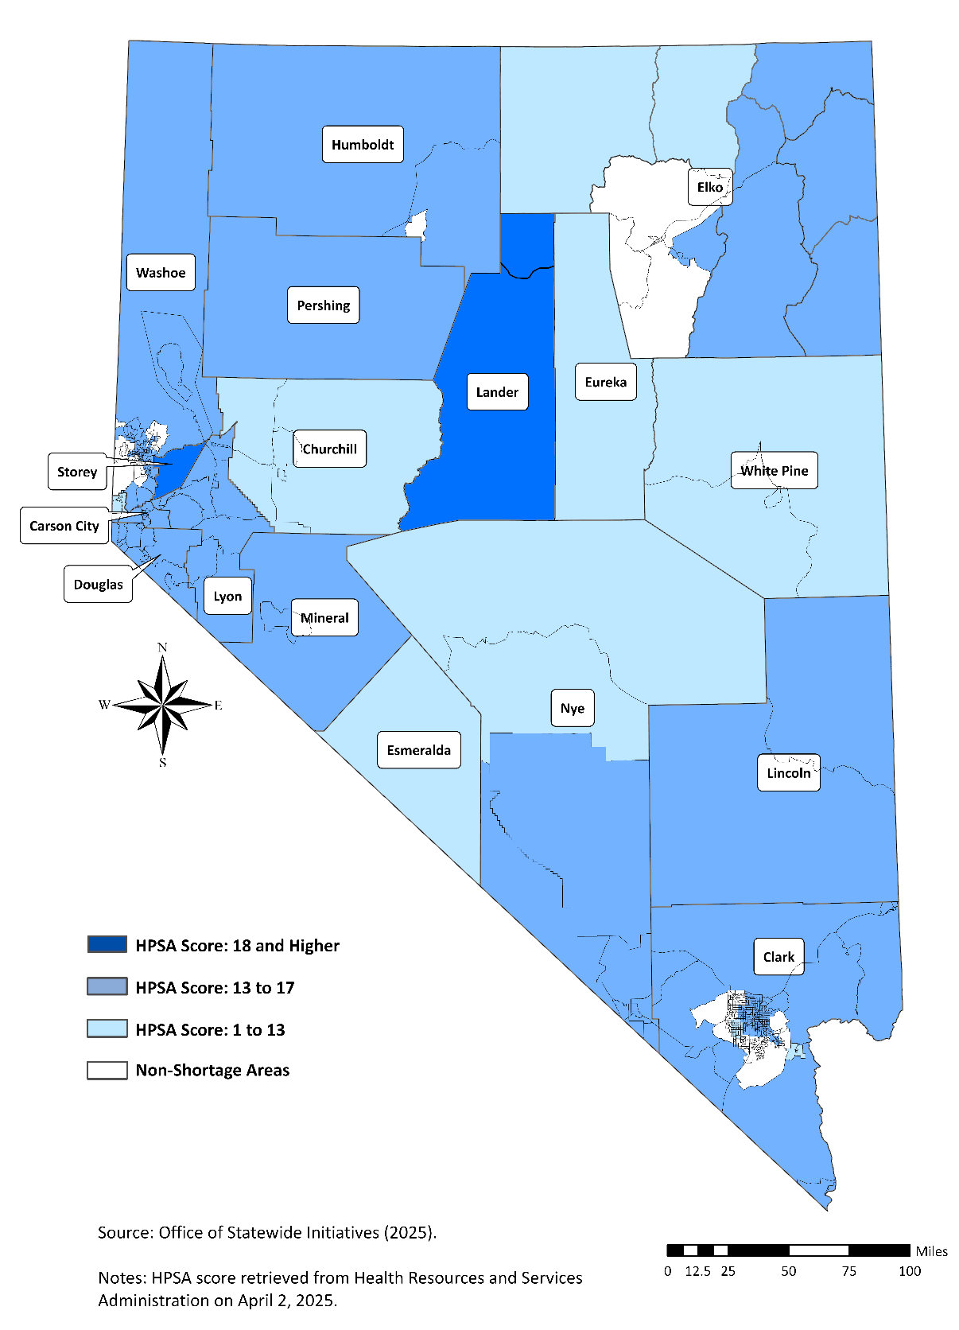

Figure 18: Primary Medical Care Health Professional Shortage Areas (HPSAs) in Nevada – 2025

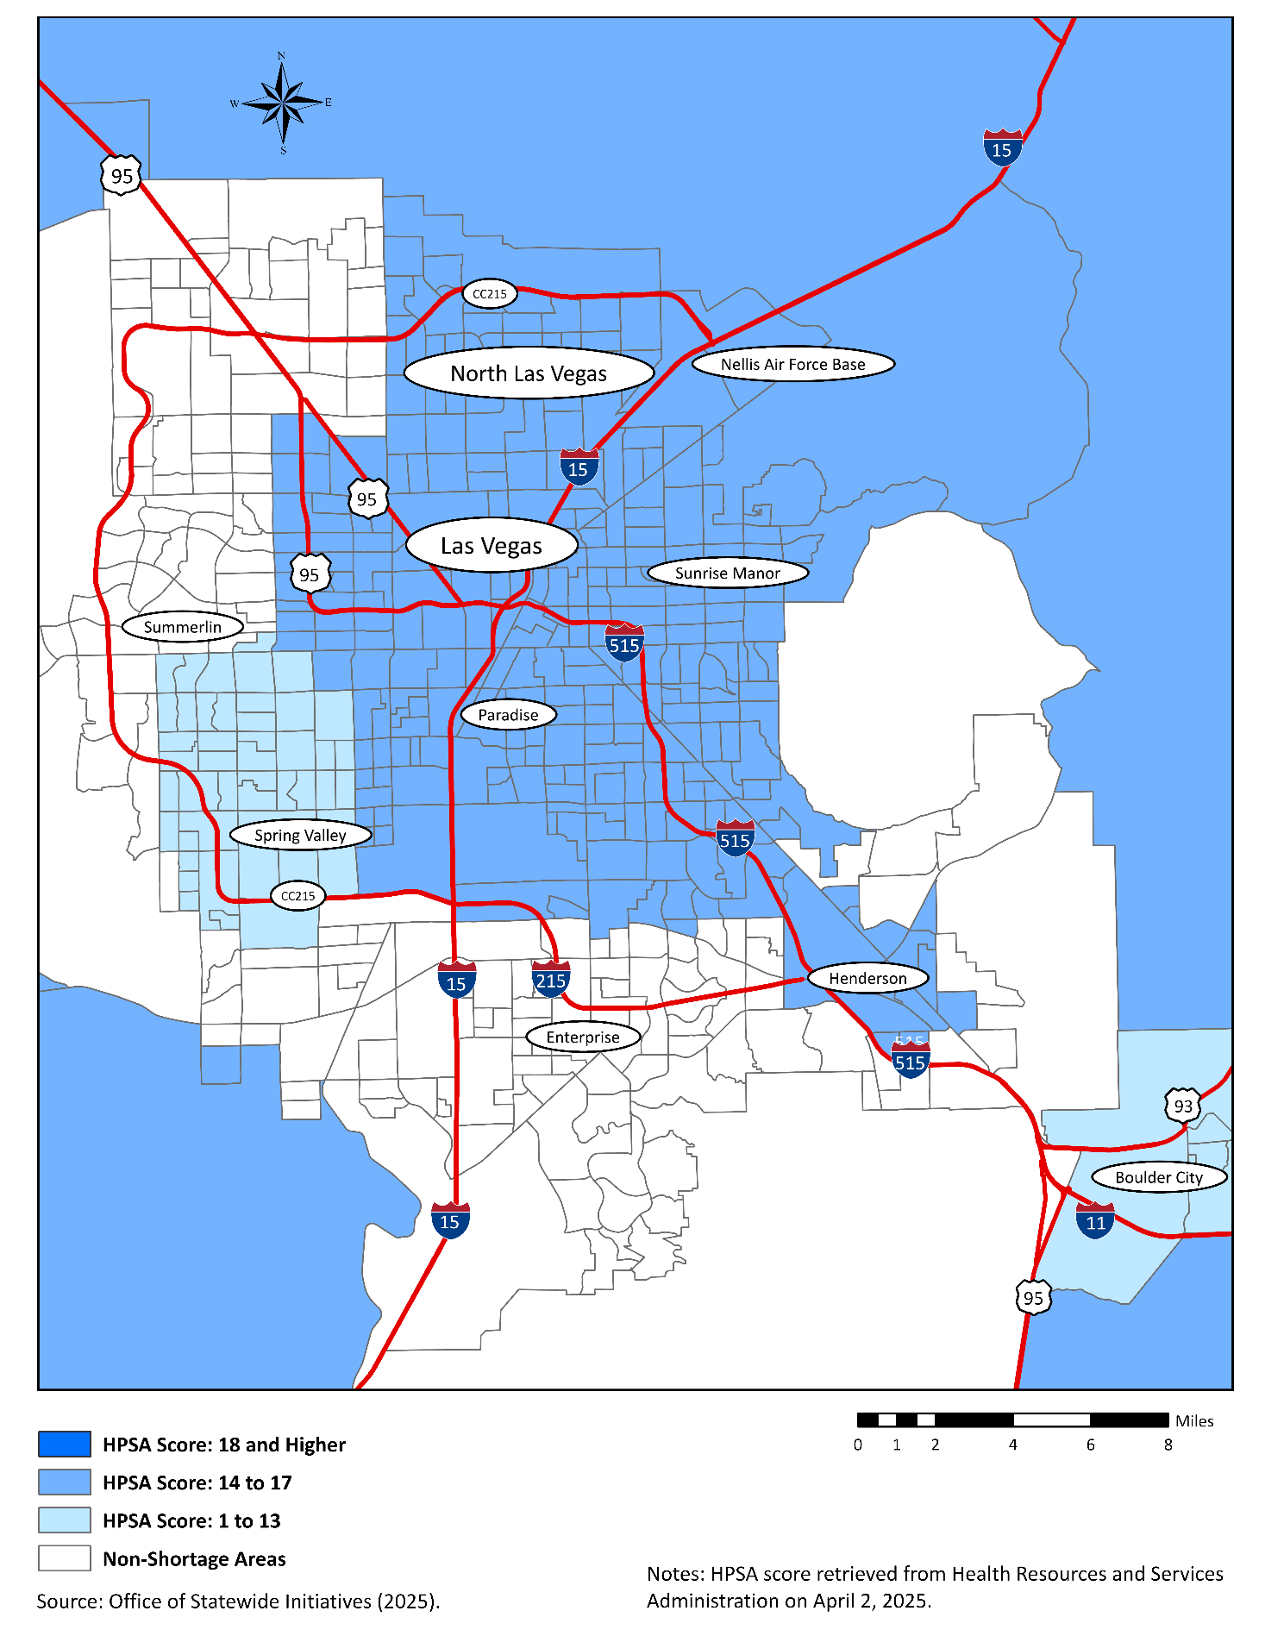

Figure 19: Primary Medical Care Health Professional Shortage Areas (HPSAs) in Southern Nevada – 2025
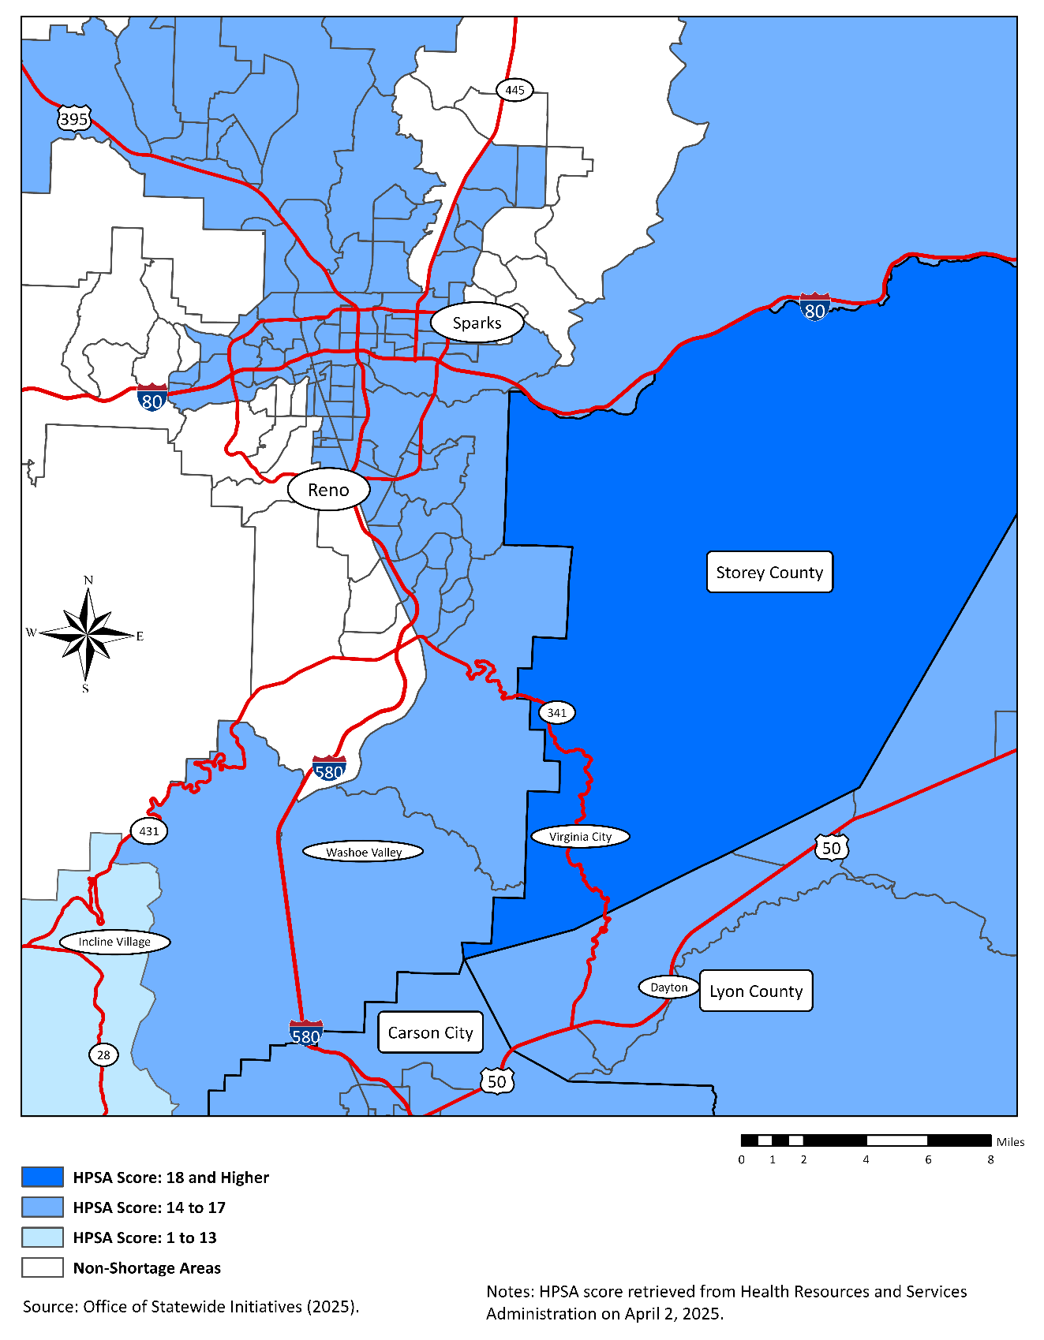

Figure 20: Primary Medical Care Health Professional Shortage Areas (HPSAs) in Northern Nevada – 2025

Figure 21: Mental Health Professional Shortage Areas (HPSAs) in Nevada – 2025
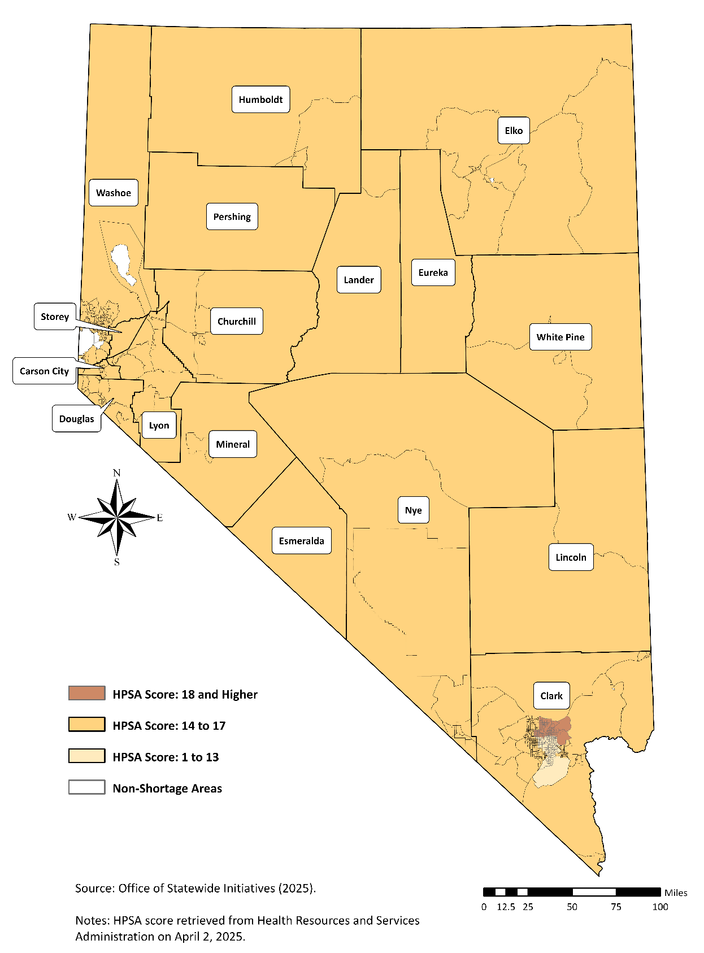
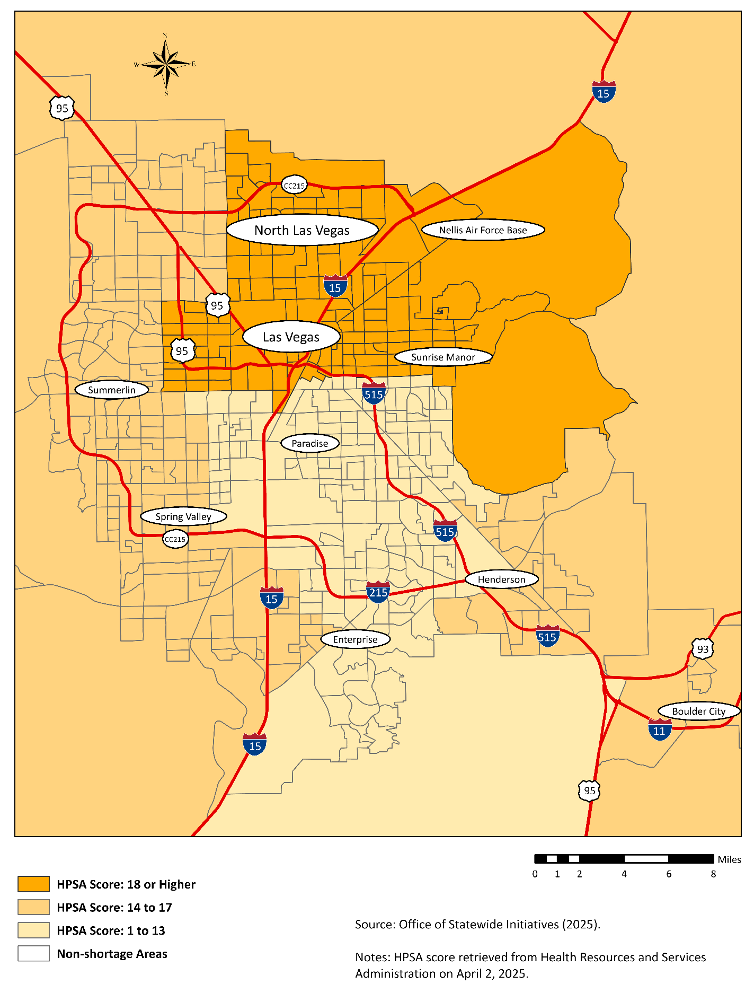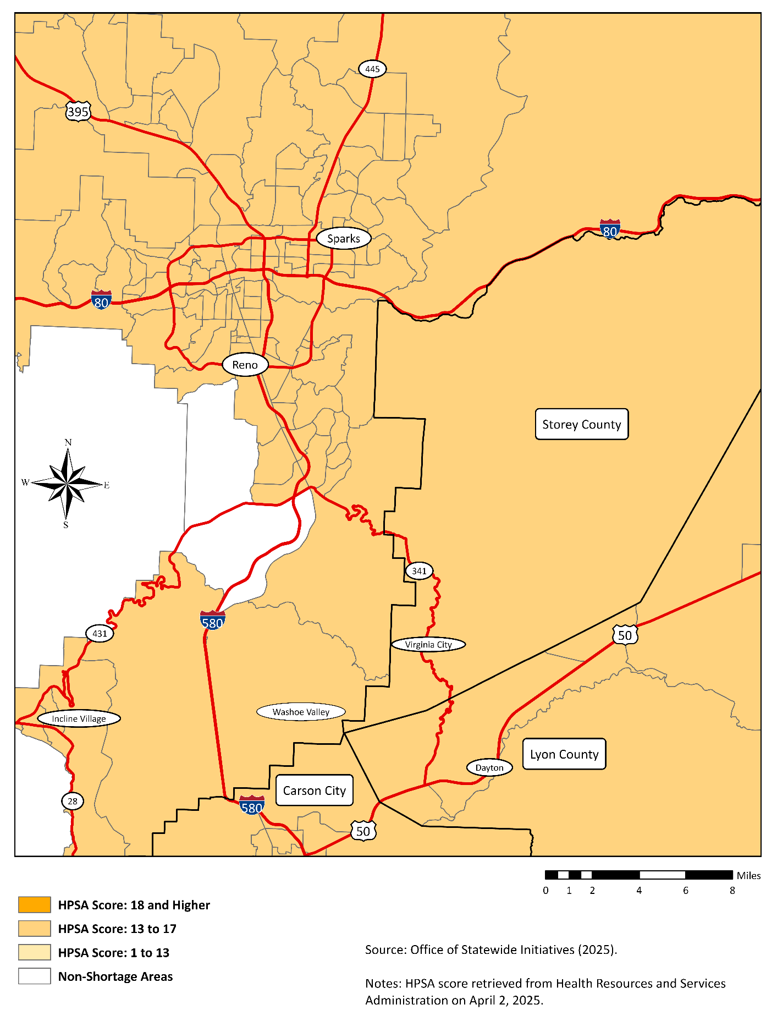

Figure 22: Mental Health Professional Shortage Areas (HPSAs) in Southern Nevada – 2025

Figure 23: Mental Health Professional Shortage Areas (HPSAs) in Northern Nevada – 2025

Figure 24: Population Residing in Health Professional Shortage Areas (HPSAs) in Nevada — 2025
Region/County | Population Residing in Health Professional Shortage Areas (HPSAs) |  |  |  |  |  | Population
Region/County | Primary Care HPSAs |  | Dental HPSAs |  | Mental HPSAs |  | Population
Region/County | Number | Percent of Population | Number | Percent of Population | Number | Percent of Population | Population
Rural and Frontier
Churchill County | 26,704 | 100.0 | 26,704 | 100.0 | 26,704 | 100.0 | 26,704
Douglas County | 54,958 | 100.0 | 54,958 | 100.0 | 54,958 | 100.0 | 54,958
Elko County | 26,260 | 46.5 | 5,183 | 9.2 | 56,498 | 100.0 | 56,498
Esmeralda County | 1,128 | 100.0 | 1,128 | 100.0 | 1,128 | 100.0 | 1,128
Eureka County | 1,992 | 100.0 | 1,992 | 100.0 | 1,992 | 100.0 | 1,992
Humboldt County | 13,899 | 78.1 | 13,899 | 78.1 | 17,793 | 100.0 | 17,793
Lander County | 6,345 | 100.0 | 6,345 | 100.0 | 6,345 | 100.0 | 6,345
Lincoln County | 4,991 | 100.0 | 4,991 | 100.0 | 4,991 | 100.0 | 4,991
Lyon County | 63,408 | 100.0 | 63,408 | 100.0 | 63,408 | 100.0 | 63,408
Mineral County | 4,834 | 100.0 | 4,834 | 100.0 | 4,834 | 100.0 | 4,834
Nye County | 53,542 | 100.0 | 53,542 | 100.0 | 53,542 | 100.0 | 53,542
Pershing County | 7,341 | 100.0 | 7,341 | 100.0 | 7,341 | 100.0 | 7,341
Storey County | 4,947 | 100.0 | 4,947 | 100.0 | 4,947 | 100.0 | 4,947
White Pine County | 10,355 | 100.0 | 10,355 | 100.0 | 10,355 | 100.0 | 10,355
Region Subtotal | 280,704 | 89.2 | 259,627 | 82.5 | 314,836 | 100.0 | 314,836
Urban
Carson City | 59,116 | 100.0 | 59,116 | 100.0 | 59,116 | 100.0 | 59,116
Clark County | 1,419,193 | 57.2 | 1,364,447 | 55.0 | 2,259,183 | 91.0 | 2,482,619
Washoe County | 436,125 | 82.5 | 287,469 | 54.0 | 456,571 | 86.4 | 528,375
Region Subtotal | 1,914,434 | 62.4 | 1,711,032 | 55.7 | 2,774,870 | 90.4 | 3,071,110
Nevada — Total | 2,195,138 | 64.9 | 1,970,659 | 58.2 | 3,089,706 | 91.3 | 3,384,946
Source: Health Resources and Services Administration (2025) and Nevada State Demographer’s Office (2025).
Notes: Data in this table are preliminary estimates of the population residing in health professional shortage areas (HPSA) at the county, regional, and state levels based on current population data from the American Community Survey and the Nevada State Demographer’s Office.

References and Data Sources
American Medical Association. (2025). AMA Physician Masterfile for Nevada. Data retrieved on December 1, 2024. https://ama-assn.org
Association of American Medical Colleges. (2025). AAMC Workforce Studies Data Snapshots. Data retrieved on April 1, 2025. https://www.aamc.org
Griswold, et al. (2024). Graduate Medical Education Trends in Nevada – 2024. University of Nevada, School of Medicine. Reno, NV. https://med.unr.edu/statewide
Griswold, et al. (2025). Nevada Rural and Frontier Health Data Book – Twelfth Edition. University of Nevada, Reno School of Medicine. Reno, NV. https://med.unr.edu/statewide
Health Resources and Services Administration. (2025). HPSA Find Tool. https://data.hrsa.gov/tools/shortage-area/hpsa-find
Nevada Instant Atlas website: https://med.unr.edu/statewide/nevada-instant-atlas
Nevada State Board of Medical Examiners (2004 to 2024). Unpublished allopathic physician licensure data. Reno, NV. For more information: http://medboard.nv.gov
Nevada State Board of Osteopathic Medicine (2004 to 2024). Unpublished osteopathic physician licensure data. Henderson, NV. For more information: www.osteo.state.nv.us
Nevada State Demographer (2025). Unpublished population estimates. Reno, NV. For additional information: https://tax.nv.gov/Publications/Population_Statistics_and_Reports
Appendix A: Definitions
This Appendix provides definitions and explanations of the specific physician attributes included in the tabulations of this publication. These materials are presented as a common reference base to facilitate analysis and interpretation of the data.

Major Professional Activity

Major professional activity (MPA) classifications are reported by physicians in the Physicians’ Practice Arrangements (PPA) questionnaire. The physician’s professional activity is shown in the two categories of Patient Care and Nonpatient Care, the latter category being referred to as Other Professional Activity.

Patient Care activities include Office-Based practice and Hospital-Based practice and Hospital-Based practice. Physicians in Residency training (including Clinical Fellows) and full-time members of Hospital Staffs comprise Hospital-based practice. Other Professional Activity includes Administration, Medical Teaching, Research, and Other Activities. The subcategory Clinical Fellows is no longer tabulated; physicians formerly counted as Clinical Fellows are now in the category Residents/Fellows and are tabulated as Residents.

Physicians who are retired, semi-retired, working part-time, temporarily not in practice, or not active for other reasons are classified as Inactive. Physicians are categorized as Not Classified if the American Medical Association (AMA) has not received any recent information as to their type of practice and present employment.

Following are definitions of each of the MPA categories.

Office-Based Practice includes physicians engaged in seeing patients. Physicians may be in solo practice, group practice, two-physician practice, or other patient care employment. This category also includes physicians in patient services such as those provided by pathologist and radiologists.

Hospital-Based Practice includes physicians employed under contract with hospitals to provide direct patient care.

Residents – All Years includes any physicians in supervised practice of medicine among patients in a hospital or in its outpatient department, with continued instruction in the science and art of medicine by the staff of the facility. This category also includes clinical fellows in advanced training in the clinical divisions of medicine, surgery, and other specialty fields preparing for practice in a given specialty. These physicians are engaged primarily in patient care.

Medical Teaching includes physicians with teaching appointments in medical schools, hospitals, nursing schools, or other institutions of higher learning.

Medical Research includes physicians in activities (funded or non-funded) performed to develop new medical knowledge, potentially leading to publication. This category also includes physicians in research fellowship programs distinct from an accredited residency program and those primarily engaged in nonpatient care.

Administration includes physicians in administrative activities in a hospital, health facility, health agency, clinic, group, or any similar organization.

Other Activity includes physicians employed by insurance carriers, pharmaceutical companies, societies, associations, grants, foreign countries, and the like.

Inactives includes physicians who are retired, semi-retired, working part-time, temporarily not in practice, or not active for other reasons and who indicated they worked 20 hours or less per week.

Not Classified includes physicians who did not provide information on their type of practice or their present employment.

Self-Designated Practice Specialty

A physician’s self-designated practice specialty (SDPS) is determined, like major professional activity, by the physician from a list of codes included with the PPA Questionnaire. Tables 1.8 and 1.9 provide all specialties listed on the PPA Questionnaire and maintained on the Masterfile for which there is at least one physician designating it as their area of practice. Specialty classifications based on the 40 specialties used by the AMA for statistical purposes are listed in Appendix A.

In the specialty tabulations presented in the Physician Trends, Physician Characteristics, Physician Distribution, and Analysis of Activity by Specialty chapters of the book, the specialties of Family Medicine (FM), General Practice (GP), Internal Medicine (IM), Obstetrics/Gynecology (OBG), and Pediatrics (PD) include both the general primary care specialties and their respective subspecialties as listed in the specialty abbreviations appearing in Appendix A. However, in the primary care chapter, the data are presented separately for the general primary care specialties and the primary care subspecialties.

Appendix B: Specialties and Subspecialties as Defined by the American Medical Association
Allergy and Immunology (AI)  Allergy (A)  Allergy and Immunology/Clinical and Laboratory Immunology (ALI)  Immunology (IG)  Aerospace Medicine (AM)  Anesthesiology (AN)  Adult Cardiothoracic Anesthesiology (ACA)  Pain Medicine (Anesthesiology) (APM)  Critical Care (Anesthesiology) (CCA)  Hospice and Palliative Medicine (Anesthesiology) (HPA)  Obstetric Anesthesiology (Anesthesiology) (OAN)  Pain Management (PME)  Cardiovascular Disease (CD)  Child and Adolescent Psychiatry (CHP)  Colon and Rectal Surgery (CRS)  Proctology (PRO)  Dermatology (D)  Clinical and Laboratory Dermatological Immunology (DDL)  Procedural Dermatology (PRD)  Diagnostic Radiology (DR)  Cardiothoracic Radiology (CTR)  Emergency Medicine (EM)  Critical Care Medicine (Emergency Medicine) (CCE)  Emergency Medical Services (EMS)  Sports Medicine (Emergency Medicine) (ESM)  Medical Toxicology (Emergency Medicine) (ETX)  Hospice and Palliative Medicine (Emergency Medicine) (HPE)  Pediatric Emergency Medicine (Emergency Medicine) (PE)  Urgent Care Medicine (UCM)  Undersea Medicine (Emergency Medicine) (UME)  Forensic Pathology (FOP)  Family Medicine (FM)  Adolescent Medicine for Family Practice (AMF)  Family Medicine/Preventive Medicine (FMP)  Geriatric Medicine (Family Medicine) (FPG)  Sports Medicine (Family Medicine) (FSM)  Hospice and Palliative Medicine (Family Medicine) (HPF)  Gastroenterology (GE)  General Practice (GP)  General Preventive Medicine (GPM)  Clinical Informatics (Preventive Medicine) (CIM)  Medical Toxicology (Preventive Medicine) (PTX)  Undersea Medicine (Preventive Medicine) (UM)  General Surgery (GS)  Abdominal Surgery (AS)  Complex General Surgical Oncology (Surgery) (ASO)  Surgical Critical Care (Surgery) (CCS)  Craniofacial Surgery (CFS)  Dermatologic Surgery (DS)  Head and Neck Surgery (HNS)  Hand Surgery (HS)  Hospice and Palliative Medicine (Surgery) (HPS)  Hand Surgery (Surgery) (HSS)  Oral and Maxillofacial Surgery (OMF)  Pediatric Cardiothoracic Surgery (PCS)  Pediatric Surgery (Surgery) (PDS)  Surgical Oncology (SO)  Trauma Surgery (TRS)  Vascular Surgery (VS) | Internal Medicine (IM)  Advanced Heart Failure and Transplant Cardiology (Internal Medicine) (AHF)  Adolescent Medicine (AMI)  Critical Care Medicine (Internal Medicine) (CCM)  Diabetes (DIA)  Endocrinology, Diabetes and Metabolism (END)  Hematology (Internal Medicine) (HEM)  Hepatology (HEP)  Hepatology/Oncology (HO)  Hospitalist (HOS)  Hospice and Palliative Medicine (Internal Medicine) (HPI)  Interventional Cardiology (IC)  Cardiac Electrophysiology (ICE)  Infectious Diseases (ID)  Clinical and Laboratory Immunology (Internal Medicine) (ILI)  Geriatric Medicine (IMG)  Sports Medicine (Internal Medicine) (ISM)  Nuclear Cardiology (NC)  Nephrology (NEP)  Nutrition (NTR)  Medical Oncology (ON)  Rheumatology (RHU)  Sleep Medicine (Internal Medicine) (SMI)  Transplant Hepatology (Internal Medicine) (THP)  Medical Genetics (MG)  Clinical Biochemical Genetics (CBG)  Clinical Cytogenetics (CCG)  Clinical Genetics (CG)  Clinical Molecular Genetics (CMG)  Medical Biochemical Genetics (MBG)  Molecular Genetics Pathology (Medical Genetics) (MGG)  Neurology (N)  Child Neurology (CHN)  Clinical Neurophysiology (CN)  Endovascular Surgical Neuroradiology (Neurology) (ENR)  Epilepsy (Neurology) (EPL)  Hospice and Palliative Medicine (Psychiatry and Neurology) (HPN)  Pain Medicine (Neurology) (PMN)  Sleep Medicine (Psychiatry and Neurology) (SMN)  Vascular Neurology (VN)  Nuclear Medicine (NM)  Neurological Surgery (NS)  Endovascular Surgical Neuroradiology (ES)  Endovascular Surgical Neuroradiology (ESN)  Pediatric Surgery (Neurology) (NSP)  Obstetrics and Gynecology (OBG)  Female Pelvic Medicine and Reconstructive Surgery (Obstetrics and Gynecology) (FPR)  Gynecological Oncology (GO)  Gynecology (GYN)  Hospice and Palliative Medicine (Obstetrics and Gynecology) (HPO)  Maternal and Fetal Medicine (MFM)  Obstetrics (OBS)  Critical Care Medicine (Obstetrics and Gynecology) (OCC)  Reproductive Endocrinologist (REN)  Occupational Medicine (OM)  Ophthalmology (OPH)  Ophthalmic Plastic and Reconstructive Surgery (OPR)  Pediatric Ophthalmology (PO)

Specialties and Subspecialties as Defined by the American Medical Association (continued)
Orthopedic Surgery (ORS)  Hand Surgery (Orthopedic Surgery) (HSO)  Adult Reconstructive Orthopedics (OAR)  Orthopedics, Foot and Ankle (OFA)  Osteopathic Manipulative Medicine (OMM)  Musculoskeletal Oncology (OMO)  Pediatric Orthopedics (PO)  Sports Medicine (Orthopedic Surgery) (OSM)  Orthopedic Surgery of the Spine (OSS)  Orthopedic Trauma (OTR)  Other Specialty (OS)  Addiction Medicine (ADM)  Pediatric Psychiatry/Child Psychiatry (CPP)  Emergency Medicine/Family Medicine (EFM)  Pediatrics/Emergency Medicine (EMP)  Epidemiology (EP)  Family Medicine/Psychiatry (FPP)  Hospice and Palliative Medicine (HPM)  Internal Medicine/Emergency Medicine/Critical Care Medicine (IEC)  Internal Medicine/Family Medicine (IFP)  Internal Medicine/Dermatology (IMD)  Internal Medicine (Preventive Medicine) (IPM)  Legal Medicine (LM)  Internal Medicine/Medical Genetics (MDG) Medical Management (MDM)  Internal Medicine (Emergency Medicine) (MEM)  Internal Medicine and Neurology (MN)  Internal Medicine/Psychiatry (MP)  Internal Medicine/Physical Medicine and Rehabilitation (MPM)  Neurology/Diagnosis Radiology/Neuroradiology (NRN) Clinical Pharmacology (PA)  Pediatrics/Dermatology (PDM)  Phlebology (PHL)  Pharmaceutical Medicine (PHM)  Palliative Medicine (PLM)  Pediatrics/Medical Genetics (PMG)  Pediatrics/Physical Medicine and Rehabilitation (PPM)  Psychiatry/Neurology (PYN)  Sleep Medicine (SME)  Otolaryngology (OTO)  Otology/Neurotology (NO)  Pediatric Otolaryngology (PDO)  Plastic Surgery within the Head and Neck (Otolaryngology) (PSO)  Sleep Medicine (SMO)  Pediatrics (PD)  Adolescent Medicine (ADL)  Child Abuse Pediatrics (CAP)  Clinical Informatics (Pediatrics)  Pediatric Critical Care Medicine (CCP)  Developmental/Behavioral Pediatrics (DBP)  Hospice and Palliative Medicine (Pediatrics) (HPP)  Internal Medicine/Pediatrics (MPD)  Neurodevelopmental Disabilities (Pediatrics) (NDP)  Neonatal Perinatal Medicine (NPM)  Pediatric Anesthesiology (PAN)  Pediatric Allergy (PDA)  Pediatric Dermatology (PDD)  Pediatric Endocrinology (PDE)  Pediatric Infectious Disease (PDI)  Pediatric/Anesthesiology  Pediatric Pulmonology (PDP)  Medical Toxicology (Pediatrics)  Pediatric Emergency Medicine (Pediatrics) (PEM)  Pediatric Gastroenterology (PG)  Pediatric Hematology/Oncology (PHO)  Clinical and Laboratory Immunology (Pediatrics) (PLI)  Pain Management (Physical Medicine and Rehabilitation) (PMP)  Pediatric Nephrology (PN)  Pediatric Rheumatology (PPR)  Pediatric Transplant Hepatology (PTP)  Pediatric Rehabilitation Medicine (RPM) | Sleep Medicine (Pediatrics) (SMP)  Sports Medicine (Pediatrics) (PSM)  Pediatric Cardiology (PDC)  Physical Medicine and Rehabilitation (PM)  Hospice and Palliative Medicine (Physical Medicine and Rehabilitation) (HPR)  Neuromuscular Medicine (NMN)  Neuromuscular Medicine (Physical Medicine and Rehabilitation) (NMP)  Pain Medicine (PMM)  Sports Medicine (Physical Medicine and Rehabilitation) (PRS)  Spinal Cord Injury (SCI)  Plastic Surgery (PS)  Cosmetic Surgery (CS)  Facial Plastic Surgery (FPS)  Surgery of the Hand (Plastic Surgery) (HSP)  Plastic Surgery within the Head and Neck (PSH)  Plastic Surgery – Integrated (PSI)  Plastic Surgery Within the Head and the Neck (Plastic Surgery) (PSP)  Anatomic/Clinical Pathology (PTH)  Anatomic Pathology (ATP)  Blood Banking/Transfusion Medicine (BBK)  Clinical Informatics (Pathology) (CIP)  Clinical Pathology (CLP)  Dermatopathology (DMP)  Hematology (HMP)  Molecular Genetic Pathology (MGP)Neuropathology (NP)  Chemical Pathology (PCH)  Cytopathology (PCP)  Pediatric Pathology (PP)  Selective Pathology (SP)  Psychiatry  Addiction Psychiatry (ADP)  Neurodevelopmental Disabilities (P and N)  Neuropsychiatry (NUP)  Forensic Psychiatry (PFP)  Pain Medicine (Psychiatry  Psychoanalysis (PYA)  Geriatric Psychiatry (PYG)  Psychosomatic Medicine (PYM))  Public Health and General Preventive Medicine (PHP)  Pulmonary Disease (PUD)  Pulmonary Critical Care Medicine (PCC)  Radiology (R)  Abdominal Radiology (AR)  Hospice and Palliative Medicine (Radiology) (HPD)  Musculoskeletal Radiology (MSR)  Nuclear Radiology (NR)  Radiology (PDR)  Neuroradiology (RNR)  Radiological Physics (RP)  Vascular and Interventional Radiology (VIR)  Radiation Oncology (RO)  Thoracic Surgery (TS)  Congenial Cardiac Surgery (Thoracic Surgery) (CHS)  Thoracic Surgery – Integrated (TSI)  Transplant Surgery (TTS)  Urology (U)  Pediatric Urology (UP)  Female Pelvic Medicine  Vascular Medicine (VM)  Unspecified (US)



